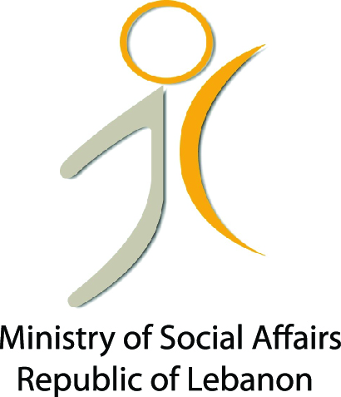
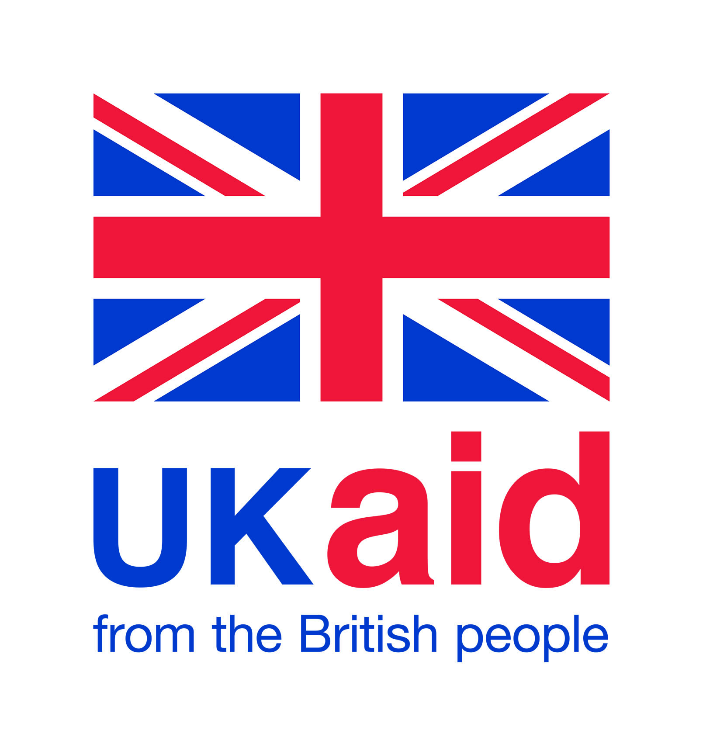
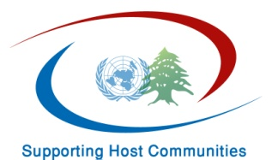

Quarterly Progress Report Number 1
Period:
October-December 2014

Summary Table
Executing Agency:

Country:

Project:

Project Duration:

Total Funds Allocated:

Reporting Period:

Contact Person:

Project Background:

Implementation Progress:
Two main activities under Social Cohesion component were implemented:
- The “Conflict Mapping/Analysis “and
- “Crisis and Conflict Management”

- For the Conflict Mapping/Conflict Analysis activity:

During the last three months the following activities were implemented:

- The map that was developed during the previous phase as a result of the partnership agreement between UNDP and Lebanon Support NGO is still active and information has been updated on a daily basis as planned. Different actors working on the crisis response as well as others have been using it and referring to it in many occasions. The tool has also been presented to key inter-agency coordination structure such as: the Bekaa Social Cohesion Working Group; the Information Management Working Group as well as during the Inter-Agency meeting.
The feedback collected on the tool has been very positive and many said how useful it is. Everyone stressed on the fact that this is a new exercise that no one did before amidst the high number of maps, but none until now covered the conflicts and incidents issues. Until December 18th 2015, around 20,888 viewed the map.

2) The first analytical report (focusing on one specific area as agreed in the workplan) has been produced after several weeks of desk and field research by the team of Lebanon Support and the lead consultant on this. This report provides an analytical summary of the conflict context in the Bekaa region of Lebanon with a focus on the relationships between refugees and the Lebanese host communities in the Baalbeck-Hermel area. It is based on a socio-political qualitative assessment and conflict analysis that is primarily based on experiences and perspectives of key informants as well as Lebanese and Syrians residents of the Bekaa. These key informants were selected to include individuals with knowledge that covers the region or the sub-region broadly and to reflect a variety of expertise, political learnings, and sectarian belonging. Existing social network of researchers was used, in addition to recommendations by civil society activists based in the Bekaa (civil society activists, relief workers, journalists, religious leaders and mayors).
The fieldwork included over 20 one to one interviews with Syrian displaced, members of Lebanese host communities, religious and intellectual figures, NGOs representatives and members of the local authorities. The report is divided into two sections: the first provides an analytical summary of the conflict context in the Bekaa region in general, using a variety of analysis tools that cover three broad dimensions of conflict: actors, issues and dynamics. In addition, the first section provides a modified political, economic, social and technological (PEST) analysis of the context in Bekaa, as well as recommendations for a conflict prevention and peace building strategy. The second section provides a case study that exemplifies how these conflict issues and dynamics are experienced by individual Syrian refugees and members of Lebanese host communities. The case study also aims to demonstrate the connections between different issues and their impact on various social groups. (Cf. the draft conflict analysis report in Annex A).
The report will be launched on January 14th. It will also be an opportunity to discuss the map and get feedback from actors.

- Crisis and Conflict Management activities:
The following activities were implemented during the last three months:
- As per the workplan, many achievements have been made in regard to the Crisis and Conflict Management component in the three clusters of Zahleh, South and Wadi Khaled.

In Wadi Khaled cluster, the process of establishing a crisis management mechanism has been followed up on and the different stages planned as per the methodology have been implemented.
The first stage which was the conflict analysis that was conducted with the eight targeted municipalities of Wadi Khaled; Amayer; Bani Sakher; El Hishi; Al Rama; El Mqaibleh; Al Fard; Khat el Petrol, and facilitated by an Individual Consultant, Mr. Jamil Moawad (developed in the previous progress report) was key for the coming phase. (Cf. the draft report in Annex B)
Following the conflict analysis, and after agreeing with the stakeholders, two retreats were scheduled aiming at validating the findings of the conflict analysis and to draft the mechanism for crisis management and design a communication strategy to disseminate and advocate for its main results.
The first retreat was organized on November 14, 15 and 16 2014, followed by a second one from November 28th to November 30th 2014 in Ehden. The idea was to get the stakeholders out of their context and be able to concentrate and focus on the response to the crisis and conflicts. 17 participants representing the eight municipalities of Wadi Khaled included mayors, deputy mayors and municipal council members. A decision was taken between them that other local actors would be engaged at a later stage, when a draft mechanism will be ready to get their feedback on it.
Pic 1

The main results of these retreats are the following:

- Agreement to draft a “Wadi Khaled Pact/Strategy for Crisis Management”
- This strategy, in order to be efficient need to cover also the historical challenges Wadi Khaled area has been facing
- Based on this reality a part of the discussion was around the main historic moments for Wadi Khaled which led to the discussion around the role of the State vis a vis Wadi Khaled. (for more details check the report on the retreats in Annex C)
- The experience of Wadi Khaled area in dealing with the crisis to date has been a positive one and any strategy should be based on it
- This Pact would detail the main challenges the municipalities are facing related to the economic, socio-cultural and security aspects.
- The Pact includes many parts which are:
- The main needs of Wadi Khaled on several levels
- The solutions they suggest to deal with these issues and as a result to the crisis including a communication plan to address the economic, socilo-cultural and security challenges
- In parallel, participants agreed seriously on going ahead with establishing a Union for the Municipalities of Wadi Khaled. The team and the consultant of UNDP held parallel meetings with the key leaders (mayors who are head of tribes) in order to push it forward in addition to a series of parallel mediation between key parties.
- This Pact proved that the municipalities of Wadi Khaled are willing to officially improve their role vis a vis the citizens and want to assume this role and be at the core of the State and its concept. The Pact also is considered by the local leaders as a mean to give a brighter image of themselves as inhabitants of Wadi Khaled and of their area.
What was remarkable during these two retreats (although each retreat lasted for three days) was the high level of participation (most of the mayors attended themselves the retreats) and engagement from the municipalities amidst the pressure they are going through and their overload in their daily work.
The municipal representatives appreciated and valued the continuous efforts from UNDP side, and the follow up on the previous phase that started in 2013 around crisis management. They felt the link between the two phases. This played a role in motivating them even more and got them to be more involved in the process.
During the coming phase, the Pact will be finalized and the outreach plan which includes facilitated sessions with key ministries, international organization and local organizations and media will be organized to share with them the crisis management plan.
Pic 2

“Most of the problems Wadi Khaled villages are facing now can be solved by the municipal Union. We will be able to face more adequately the safety and security issues and I am sure that the development projects in the area will increase and will be able to implement more projects and at a bigger scale”, Municipal Member from Khat el Petrol Municipality.

“The Pact we are developing is an excellent strategy for us at the local level. It entails a clear vision and will help us in crisis management. It is a holistic strategy that we can rely on to communicate with governmental agencies and international organizations. I can say that it will benefit both Lebanese and Syrians”, Mayor of Hishi Municipality).

In Zahleh and South clusters, the process took a slightly different direction. The main reason was that UNDP didn’t previously work with these municipalities on crisis management issues (which is not the case of Wadi Khaled cluster). For this cluster and South one UNDP recruited a professional company which has a long outstanding experience in empowering local leaders and local actors in dealing with crisis and coming up with sustainable solutions.
Actors mapping and Conflict Analysis
As a start several meetings were held with different beneficiaries, community leaders, mayors and municipal representatives from the following municipalities:
- South: Ghazieh, Baysarieh, Cheb’a, Hibbariyyeh, Sarafand, Borj Chemali, Khiyam
- Central Bekaa: Zahleh, Bar Elias, Majdel Anjar, Taalbaya, Saadnayel, Terbol
During this phase, data was collected as a primary one aiming at understanding the context, the nature and types of tensions and the main challenges for municipalities.
Also, it was an opportunity to identify potential participants from stakeholders and actors from each municipality. Meetings with UNDP Area managers from the Social and Local Development Portfolio were also conducted to get their input and make sure to coordinate any activity that will be designed and implemented. Then the secondary data was collected using several tools: data from the UNDP/Lebanon Support Conflict Map was extracted, desk review of existing reports, strategies, media coverage of incidents and conflicts, best practices related to the clusters and social cohesion cases from around the world.
Following this, meetings with the stakeholders and municipalities were held in order to:
- Build the trust, identify further potential community leaders and local actors involved in the issues related to local crisis management and local conflicts related to the impact of the Syrian crisis on the host communities targeted.
- Request the nomination of key people to represent the municipalities (mayors, deputy mayors, fixed employees representing different municipal departments, etc.)
- Understand the reality of the conflict from different perspectives (local authorities vs community leaders and citizens)
- Inviting stakeholders identified and municipal representatives to the coming work sessions
Following this step, between October and November 2014 four retreats were organized for each of the clusters’ representatives in order to analyze local conflicts and understand underlying dynamics and testing readiness to engage and educate different stakeholders on their role in the social cohesion process. These two days retreats (15 to 20 participants in each session) were organized for the municipalities’ representatives (including mayors, deputy mayors, municipal council members , fixed employees representing different municipal departments( alone from one side and for the stakeholders (Lebanese and Syrians including social activists, community leaders, volunteers , active people at the local level and involved with different local and INGOS that target Lebanese or Syrian through humanitarian or development projects , local religious figures / local religious leaders) alone from another side.
The results of these sessions lead to the finalization of the conflict analysis. These analysis highlighted three major aspects with their main findings (for more details cf. draft conflict analysis reports of Central Bekaa and South in Annex D and E):
For Central Bekaa and the municipalities of: Zahleh, Bar Elias, Majdel Anjar, Taalbaya, Saadnayel, Terbol:
- Political and safety/security aspect:
- The pre-crisis clashes among the Lebanese form a convenient ground for re-enforced tensions upon the entry of Syrian refugees
- The spillovers of the Northern Bekaa are affecting the Central Bekaa region
- Some municipalities in Central Bekaa are setting social pressure on Syrian refugees
- Clashes within the Informal Temporary Settlements for various personal reasons
- Socio Economic aspect:
- Municipalities’ capacity to provide public services is limited
- Some employers are abusing Syrian workers by underpaying them
- There has been an increase in competition over jobs and resources
- The increase in rent is causing social pressure on the bulk of the local society
- The crisis has led to cut in trade relationship and routes between Lebanon and Syria
- International donors of aid are often mismanaging their processes leading to increased social tensions
- Socio Cultural aspect:
- There has been a high perceptions of existential, symbolic, and status-honor threats
- Religious instructions regarding marriage are changing the existing familial patterns
- Political and concessional parties are making use of the situation to increase their popularity
- Acts of generalization and discrimination within the societies
For South and the municipalities of: Ghazieh, Baysarieh, Cheb’a, Hibbariyyeh, Sarafand, Borj Chemali, Khiyam:
- Political and safety/security aspect:
- Violent reactions towards refugees resulting from the death of Hezbollah fighters in Syria
- Fear of Syrian opposition militant groups crossing the borders from Syria to Lebanon through Chebaa
- High pressure and surveillance put on refugees in the villages
- Socio Economic aspect:
- Municipalities’ limited capacity to provide services
- Increased competition over jobs and resources
- Education and health issues
- International donors are mismanaging aid and corruption is spread within local NGOs and local actors working with NGOs
- Socio Cultural aspect:
- Lebanese men marrying Syrian women
- More cases of prostitution are being observed and identified causing local tensions and accusations to Syrian refugees
- Differences in traditions, customs and norms in addition to religious differences
It is worth mentioning that participants, especially the local stakeholders expressed their gratitude that the retreats gathered both Lebanese and Syrians in order to conduct the conflict analysis. For them, it was the first them that they sit together and share information regarding the conflicts and talk honestly and clearly of the different issues. The participation of Syrians was key in order to get the full picture and hear their concerns and understand better the reality they are living in. this methodology was also key to be able to design realistic and comprehensive solutions.
The Mechanisms for Social Stability
After conducting these conflict analysis, retreats gathered municipal representatives with local actors from the two clusters (in separate retreats) to suggest and discuss potential solutions for the three main conflict drivers: the socio-economic, socio-cultural and security; ie the Mechanisms for Social Stability. The approach was developed bearing in mind the challenges at the three levels and aiming to help municipalities and local actors achieve the following objectives:
- Promoting social stability by addressing social, economic and security challenges facing both Lebanese communities and Syrian displaced
- Investigating the role of municipalities in mitigating conflict and managing the crisis through capacity building and securing financial and human resources
- Building trust between the municipality and citizens, donors, displaced and civil society through a long term strategy for mitigating conflict and alleviating the crisis
It is important to mention that these mechanisms suggested below are in many cases based on existing mechanisms used by the municipalities in dealing with the crisis (which was felt by participants and appreciated). Of course, the specificities of each area were also taken into consideration (which is why the conflict analysis phase is essential in such processes).
Retreats for Central Bekaa and South clusters were organized simultaneously on December 10 and 11 and December 20, 21st. Around 30 persons took part in each of the retreats.
The main expected results developed and discussed during the retreats for the three areas are:
The Socio-Economic Mechanism for Social Stability (it is important to mention that we had to include the socio-economic component because it is in reality one of the main triggers of conflict and that it need to be tackled- as for the results suggested below and pertaining the actual implementation and follow up will be communicated to the proper department at UNDP which is the Social and Local Development portfolio with whom a close cooperation is being done in order to complement the work with the one done under MRR process. In this regard, the results developed here are considered to be at the macro level):
Expected Results | The suggested mechanisms
Create and investigation in businesses that solve socio-economic problem | Establishing a committee by the municipality that includes, local civil society, business leaders, women, youth and diaspora members
Create job opportunities especially among youth | Designing and launching “an entrepreneurship competition” initiative, which consists of collecting innovative and sustainable socio-economic projects/mechanisms presented by local citizens
Engage local communities in the search for socio-economic mechanisms | Providing technical assistance for entrepreneurship projects through specialized support by NGOs and local businesses
Reposition the role of the municipality as an instigator of socio-economic growth | Provide municipalities with a suitable working space that can serve as an incubator with projects presented.

The Socio-Cultural Mechanism for Social Stability:
Expected Results | The suggested mechanisms
Decrease violent conflicts caused by cultural, social, religious and political differences | Planning and implementing periodical cultural, sports, arts and social activities that bring together Lebanese with different backgrounds as well as Lebanese with Syrians (exhibitions, choirs, movies…)
Increase joint social and cultural activities and initiatives | Facilitating dialogue between Lebanese-Lebanese and Lebanese-Syrians to reduce discrimination and to develop a common declaration of respect for human rights and individuals
Shift the depiction of Lebanese-Lebanese, Syrian-Syrian and Syrian-Lebanese relations towards a more positive outlook | Liaising with national and international human rights organizations to set criteria for local standards
Reduce actors of discrimination and violation of human rights | Training a team of monitors to document and report exceptional cases of abuses or discrimination towards either Syrians or Lebanese
Create a platform for a real dialogue between Lebanese among each other and with Syrians to understand and overcome historical differences | Developing a media strategy that highlights the positive cultural and social relationships and diffuses tensions between Lebanese among themselves and Lebanese with Syrians

The Security Mechanism for Social Stability:
Expected Results | The suggested mechanisms
Decrease crimes and violent assaults (including rape, theft, beatings) | Establishing and building the capacity of a unit comprised of local police and municipal members
Prevent violent conflicts between the Lebanese and the Syrians | Developing a data management system that collects information from: local partners (Syrian and Lebanese) and from local police
Equip the municipalities with mediation tools to help them intervene and prevent violent conflicts | Analyzing and validating information through local networks
Replace existing security measures (such as curfews and local informal armed groups) with effective non-violent, preemptive measures | Relaying data to security forces in case there is a need for intervention

“Municipalities should be more involved in the crisis management. They should really be thinking of solutions for the economic, socio-cultural and security plans; which is needed to respond to this crisis but also to build our resilience for the years to come”, community leader from the South.

Pic 3 (bekaa)

Pic 4 (south )
“After more than three years of the crisis, it is time to draw a crisis management plan under the leadership of the municipalities, that represent the State at the local level”, Municipal official from Central Bekaa.
“What is happening during these retreats is so important to build our resilience and be ready to face any crisis whether linked to the Syrian crisis or not. This is crucial for our own development as developing countries”, municipal official from the South
During the retreats, each municipalities representatives sat together and developed the different solutions, endorsed some and suggested others. They were asked after to go back to their municipalities, consult with whoever needs to be consulted with and send their customized plans by one week time to UNDP. The next phase would entail conducting additional meetings with the leaders of each municipality in order to enter the next phase which is the implementation of the plans.
The main highlight of these retreats was that the project was able to gather municipal representatives and local stakeholders in the same retreats. Many participants said that this is the first time that the local civil society sits with the local leaders and share views and discuss and come up with solutions that serve the interests of the local community. It was a clear opportunity for municipalities to get innovative and new ideas from youth leaders, from young businessmen, from local professional actors in different domains to solve many of the economic, social, cultural and security problems. It was a clear opportunity as well for both actors: municipalities and civil society actors to consider the public interest of their local communities as a joint responsibility. It was an opportunity for the municipalities to think that they should invite non-elected actors to think with them of solutions for the several problems; as much as it was an opportunity for local actors to assume their role as well and realize that they have a responsibility to fill as well and not remain passive actors waiting for the local authority to come up with solutions. This led definitely to a change in the culture and ensured a better accountability and thus a better quality of life.
“The main achievement you did today is that you were able to gather local authorities and local actors in the same room and get them to listen to each other and think together of solutions. This is unique because in many cases the municipalities represent a certain political party. So getting the feedback of other local civil society stakeholders gives the other side of the story. This is a first at least in our area”, activist in a local NGO from the South.
What was also remarkable was the vibrant discussions during the retreats. Many considered that this is the first time they meet to come up with solutions and not just discuss and analyze the status-quo. Participants didn’t mind spending whole days in the retreat, leaving their families, jobs and other businesses.
What was also interesting is that some participants volunteered to put pressure on other participants to attend and make sure they don’t miss the retreat.
After the retreats each of the municipalities was assigned to drat

Implementation Arrangements:
- Relationship / coordination with Ministry of Social Affairs
- Relationship with DFID/UK to serve the host communities
- Organigram outlining the project team structure
Challenges:
- The sudden death of Lebanon Support Director and Lead Expert which delayed the finalization of the conflict analysis report and its launch. This launch was delayed till January 2015.
- The volatile security situation which affects the implementation of the work that is targeting hot spot areas.
- The sensitivities of the strategies we are developing at the local level and the extra time needed for the facilitation process and the negotiation with the different stakeholders.

Lessons Learned:

The methodology used for the conduction of the conflict analysis and the development of the mechanisms adopted an individualized approach targeting each and every municipality and local actors taking input from each side in order to capture all elements of the conflicts, all dynamics, trends, etc., even though the process targets the cluster of the eight villages all together . The individual meetings through the in depth interviews conducted proved to be very important in building trust and providing a safe space for people to express freely about the inter and intra local conflict in their villages. Many interviewees have expressed that each municipality has its privacy and each mayor or deputy mayor needs a private space sometimes to express honestly and in a transparent manner his perception / opinions / needs in the area / local conflicts between the villages and conflicts.

Financial Status:

- Actual expenditures as of to date.

 | Total Budget | Received Amount | Expenditure | Commitment | Remaining
Total Amount | $555,000.00 | $555,000.00 | $49,990.63 | $233,895.15 | $271,114.22
8% F&A | $44,400.00 | $44,400.00 | $3,999.25 | $18,711.61 | $21,689.14
Grand Total | $599,400.00 | $599,400.00 | $53,989.88 | $252,606.76 | $292,803.36
 |  | 100.00% | 51.15% |  | 48.85%

- Commitments for next tranche.

Reporting on Results and Impact:
Outcome | Outcome Indicators | Target | Progress | Pending Issues / Reasons for Adjustments
Output | Output Indicators | Target | Progress | Pending Issues / Reasons for Adjustments

Planning for the Next Period:

- By the end of March, the formulation of Social Stability Mechanisms in the three clusters of Wadi Khaled, Zahleh and South will be developed and implemented.
- The second periodic conflict analysis report produced in collaboration with Lebanon Support focusing on the South will be ready
- The incident/conflict map will be updated and enhanced

Annexes:
- Annex A: Key events / project activities

- Conflict Analysis report produced by Lebanon Support
- Draft Conflict Analysis report for Wadi Khaled
- Draft report on Wadi Khaled retreats
- Draft Conflict Analysis report for Central Bekaa
- Draft Conflict Analysis report for South
- Report on the Mechanisms for Social Stability

- Annex B: Procurement schedule

